**Sterimax**

1. Image for Home **About Us** Section
2. Image of 3 Clients for **Testimonial (** Also give founder and Co-founder image if it is possible )
3. 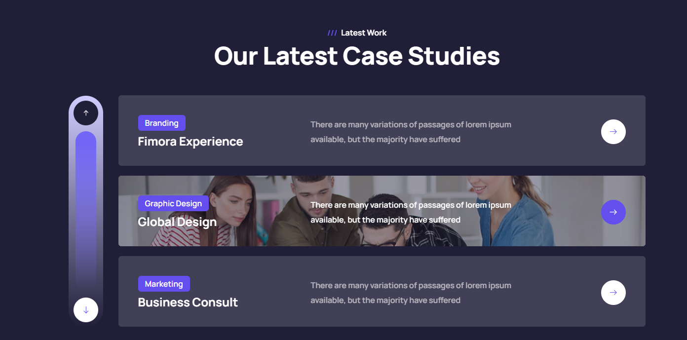5 Image **case studies** with Name of case and 2 line description Like given Exp...
4. 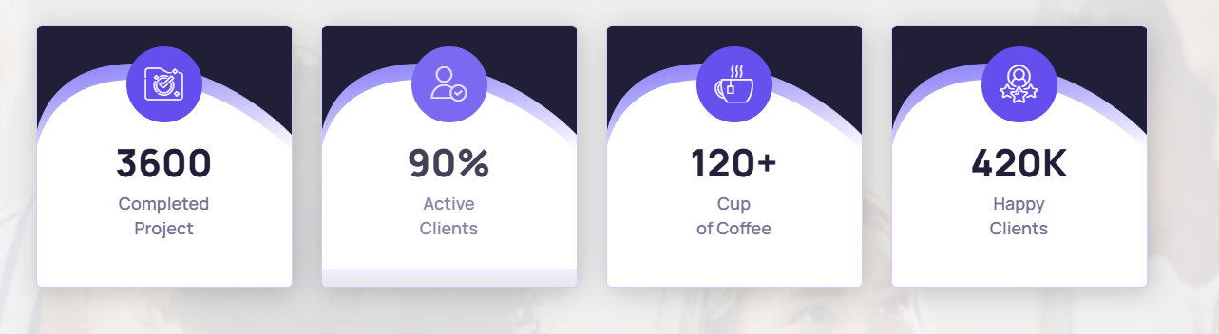Also need this Proper details
5. **Need Team Name with Image**

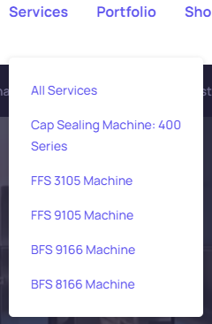

1. **Need All machine Name With photo**

If it is possible can you capture all Working

Time Machine video then pls take it and send

1. Also Need facility Working time carpet area video
2. Need All Image with title for Gallery
3. Need Your all Client with Logo.

…………………………………………………………………………………………………………………………………………………………….